REDC Consortium Virtual Advocacy Day 2021 – Social Media Toolkit
Wednesday, February 10, 2021

Background: The REDC Consortium brings advocates together on a yearly basis to educate Members of Congress and advocate for policy initiatives. This year, the advocacy day will be focused on the SERVE Act in an effort to expand access to eating disorders treatment for military families, and increase identification and treatment of servicemembers.
If you’re participating in the advocacy day, or you or members of your organization are unable to take part in this year’s advocacy day, there are still ways to connect with the offices of your Members of Congress and influence eating disorders policy. This toolkit provides information on our upcoming Action Alert produced in partnership with the Eating Disorders Coalition for Research, Policy & Action (EDC), sample Tweets, Facebook posts, Instagram captions, and images you, your colleagues, and treatment centers can use to urge Members of Congress to support REDC advocacy efforts around the SERVE Act.
Action Alert:
On February 10 during the REDC Consortium Virtual Advocacy Day, the Action Alert campaign will go live via the link here. To spread the word, we encourage you, your colleagues, and treatment centers to use the social media messaging below to increase visibility and support of the SERVE Act.
To make the largest impact, please post language/images only on Wednesday, February 10, 2021.

- Twitter Sample Tweets
  - We need your support now to encourage your Members of Congress to co-sponsor the recently reintroduced #SERVEAct, which would substantially improve access to eating disorders care for servicemembers and their families: https://p2a.co/xhXFq7
  - The #SERVEAct was just reintroduced in Congress! Make your voice heard on Capitol Hill today by clicking the link and telling your Members of Congress why #MilitaryEatingDisordersCare is important to you! https://p2a.co/xhXFq7
  - Urge @HASCDemocrats, @HASCRepublicans, @SASCDems & @SASCGOP to include the recently reintroduced #SERVEAct within their FY22 #NDAA requests and support #MilitaryEatingDisordersCare: https://p2a.co/xhXFq7

- Facebook Sample Posts
  - We need your support now to encourage your Members of Congress to co-sponsor the recently reintroduced #SERVEAct, which would expand access to eating disorders treatment for military family members, as well as bolster efforts related to the identification and treatment of eating disorders among servicemembers themselves. Click here to participate: https://p2a.co/xhXFq7
  - The #SERVEAct was just reintroduced in Congress! Make your voice heard on Capitol Hill today by clicking the link and telling your Members of Congress why #MilitaryEatingDisordersCare is important to you and why they should support the #SERVEAct! https://p2a.co/xhXFq7
  - Urge @HASCDemocrats & @HouseArmedServicesCommitteeRepublicans, as well as Senate Armed Services Committee Democrats and Republicans, to include the recently reintroduced #SERVEAct within their FY22 #NDAA requests and support #MilitaryEatingDisordersCare: https://p2a.co/xhXFq7

- Instagram Sample Posts
  - We need your support now to encourage your Members of Congress to co-sponsor the recently reintroduced #SERVEAct, which would expand access to eating disorders treatment for military family members, as well as bolster efforts related to the identification and treatment of eating disorders among servicemembers themselves. Click here to participate: https://p2a.co/xhXFq7
  - The #SERVEAct was just reintroduced in Congress! Make your voice heard on Capitol Hill today by clicking the link and telling your Members of Congress why #MilitaryEatingDisordersCare is important to you and why they should support the #SERVEAct! https://p2a.co/xhXFq7
  - Urge House Armed Services Committee and Senate Armed Services Committee Democrats and Republicans to include the recently reintroduced #SERVEAct within their FY22 #NDAA requests and support #MilitaryEatingDisordersCare: https://p2a.co/xhXFq7

- Social Media Graphics
  - Use the graphics below in conjunction with the social media post above.

Twitter
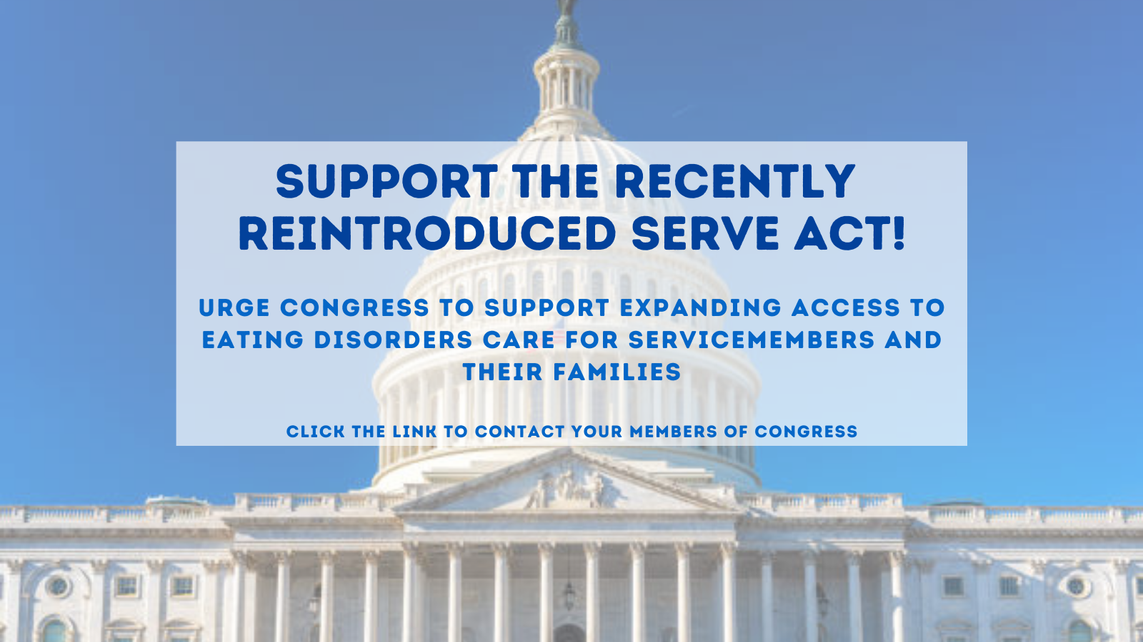

Instagram

Facebook

