Eating Disorders Coalition for Policy, Research & Action Eating Disorders Awareness Week Tool Kit
February 21-February 27, 2022

Hello EDC Members and EDC Ambassadors!
Thank you for participating in National Eating Disorders Awareness Week from Monday, February 21st- Sunday, February 27th!
Below you will find images and captions that can be used throughout the week. We have the images in order of the days the EDC will be sharing them. If you choose to use the images, please be mindful of the date you are sharing.
You can also find formatted images for Facebook, Twitter, and Instagram in our Dropbox: https://bit.ly/3sOovn5.
To ensure consistency, please use the hashtag #eatingdisordersawareness week with the posts.
If you have any questions or concerns, please contact Emily Rosenberg at erosenberg@eatingidisorderscoalition.org

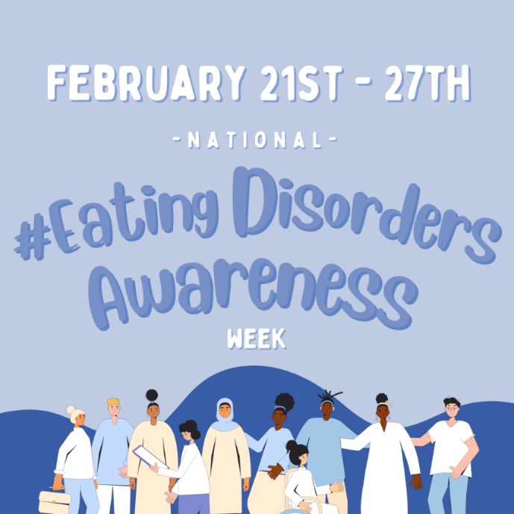
Monday, February 21: Opening Day!
Caption Facebook/Instagram: Today is the first day of National #eatingdisordersawarenessweek! Eating disorders are serious and complex mental illnesses that, unfortunately, too often go underrecognized. February 21st through the 27th is dedicated to raising public awareness, educating on the reality of #eatingdisorders, and providing support and visibility to all the individuals and families affected by this illness. Follow along with us here and on @edcoalition’s page throughout the week to learn more about eating disorders, events, and legislative initiatives!
Caption for Twitter: February 21st through the 27th is National #eatingdisordersawarenessweek! This week is dedicated to bringing public awareness to #eatingdisorders and providing education. Follow us and @edcoalition throughout the week to learn more about eating disorders, events, and legislative initiatives!

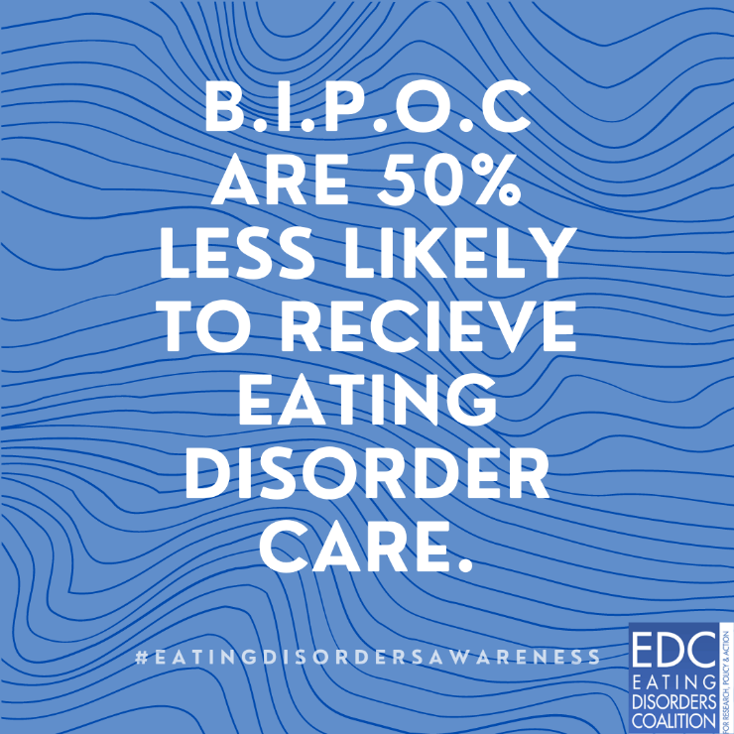
Caption for Facebook and Instagram: Eating disorders affect everyone of all races and ethnicities, but unfortunately, Black, Indigenous, and People of Color (BIPOC) experiencing eating disorders often go unrecognized and are half as likely to ever receive an #eatingdisorder treatment.
Disparities in treatment access and affordability, stigma, discrimination, and feeling underrepresented in the recovery community are all barriers that play a large role in preventing diagnosis and treatment of an eating disorder for BIPOC.
It is vitally important that we continue to make space for and uplift BIPOC voices and address the barriers that exist to make eating disorder treatment equitable and accessible. #eatingdisordersawarenessweek
Caption for Twitter: Black, Indigenous, and People of Color are 50% less likely to receive #eatingdisorder treatment. It is crucial that we address barriers that exist in making eating disorder treatment accessible and equitable for everyone. #eatingdisordersawarenessweek

Tuesday, February 22: Policy Day
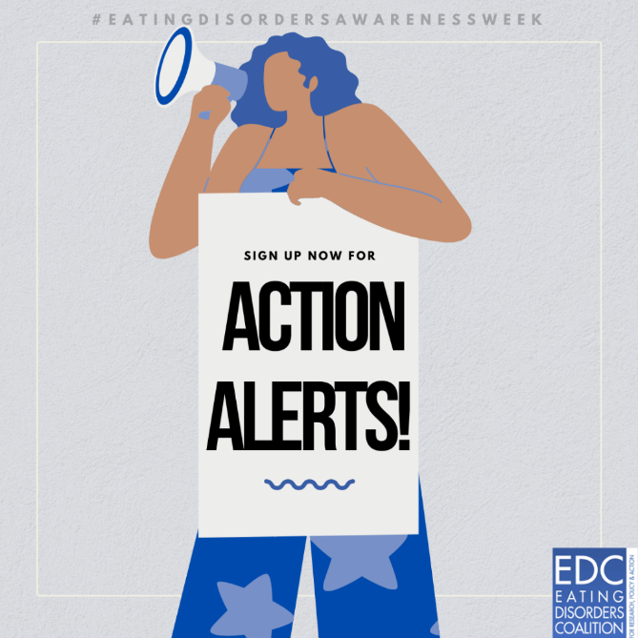

Caption for Facebook/Twitter/Instagram: Looking for ways you can get involved this #eatingdisordersawarenessweek – and every week? Sign up now for EDC Action Alerts! You will get text and email notifications when the @edcoalition needs your help to reach out to your Members of Congress on urgent #eatingdisorder policy matters. Sign up today! https://bit.ly/31xd75B
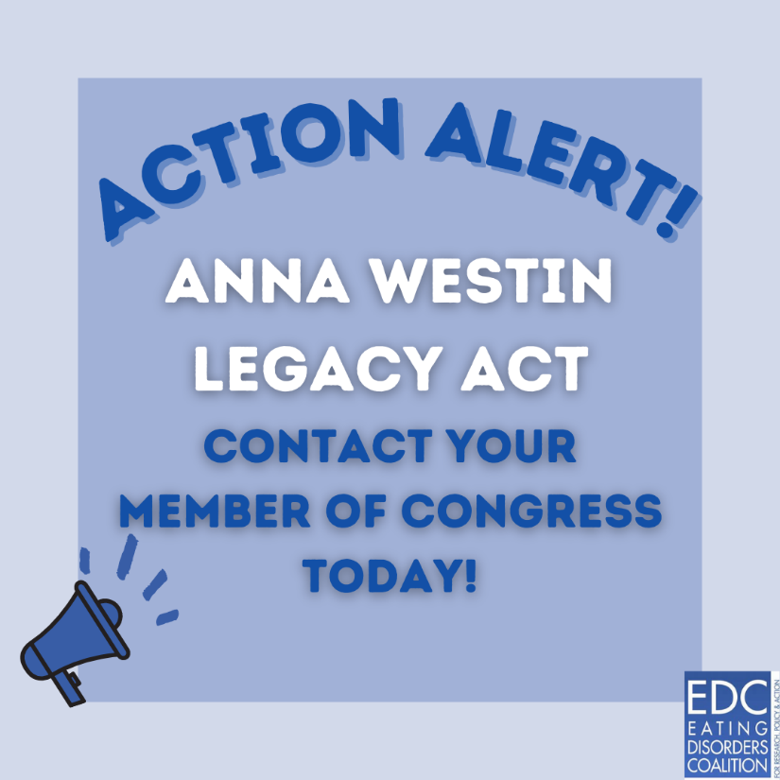
ANNA WESTIN LEGACY ACT
Caption for Facebook/Instagram: The Anna Westin Legacy Act will authorize the Center of Excellence for Eating Disorders to train health care professionals in order to screen, briefly intervene, and refer treatment for individuals with #eatingdisorders.

Help pass the legislation by urging your Senator to co-sponsor this important legislation! https://bit.ly/33qscXG. #eatingdisordersawarenessweek #eatingdisorders

Caption for Twitter: The Anna Westin Legacy Act authorize the Center of Excellence for Eating Disorders to continue providing training and resources about #eatingdisorders to health providers. Help pass the legislation by urging your Senator to become a co-sponsor. Click here to take action: https://bit.ly/33qscXG.

IMPROVING MENTAL HEALTH AND WELLNESS IN SCHOOLS ACT
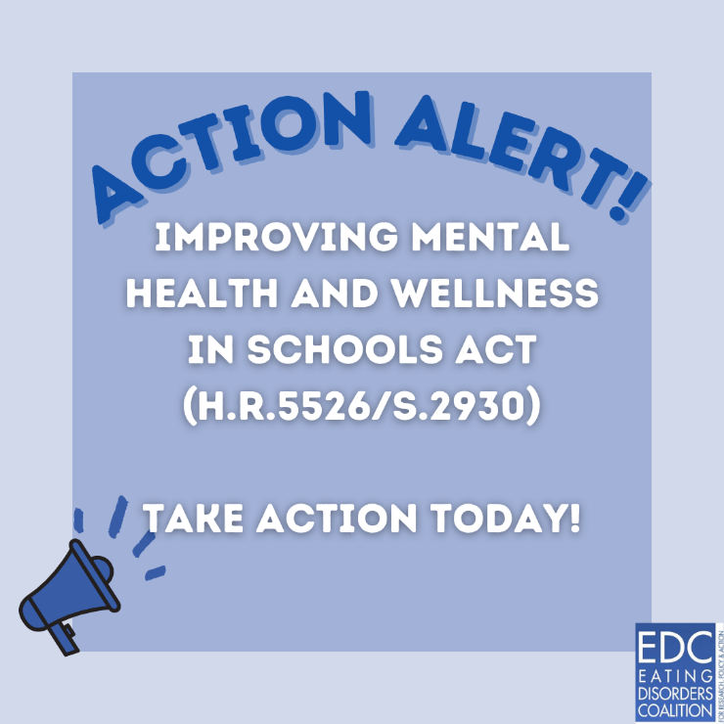
Caption for Facebook/Twitter/Instagram: The Improving Mental Health and Wellness in Schools Act will add #MentalHealth education and resources to school’s local wellness policies. Currently, only physical and nutritional health are taught. Contact your Members of Congress to them why #MentalHealth is just as important as physical health! Take action here: https://bit.ly/3oT9n77.

Wednesday, February 23
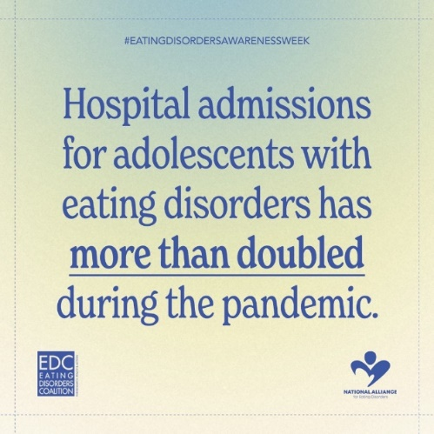
Caption for Facebook/Twitter/Instagram: Join us on Instagram, February 24th at 12pm EST, over on @hhsgov for an Instagram live in honor of national #eatingdisordersawarenessweek! Featuring speakers Admiral Rachel Levine, Good Morning America’s @ginger_zee, actress and author @reddonovan, and moderated by @alliancefored’s Lisa Murano.
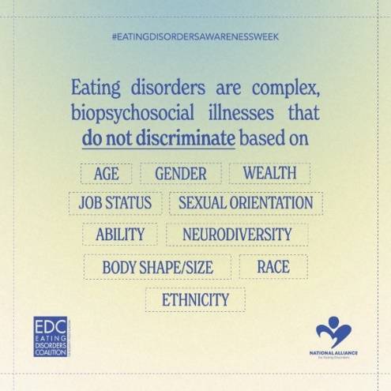
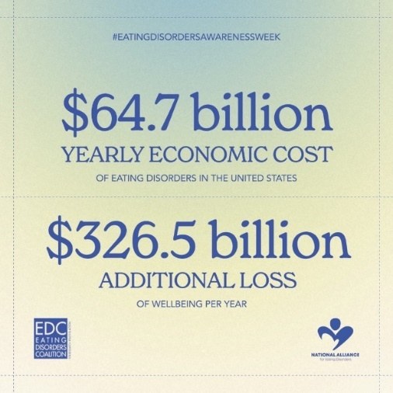
Caption for Facebook/Instagram/Twitter: In the fight against eating disorders, it’s important to remember that they are complex illnesses that have many intersecting biological, psychological, and social factors. They do not discriminate; anyone can experience an eating disorder regardless of age, gender identity, wealth status, job status, sexual orientation, ability, neurodiversity, body shape or size, race, or ethnicity #eatingdisordersawarenessweek
*All three images will be shared in one post.
Thursday, February 24
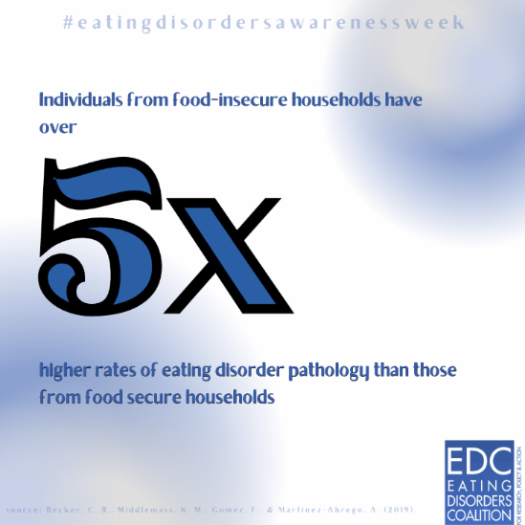
Caption for Facebook/Instagram: Did you know? Individuals from food-insecure households have over 5x higher rates of #eatingdisorder pathology than those from food-secure households. People experiencing high food-insecurity report higher levels of binge eating, weight-stigma, dietary restraint, and were found to have an overall increased risk of developing an eating disorder – particularly Binge Eating Disorder and Bulimia.
Caption for Twitter: Caption: Individuals from food insecure households have been found to have an overall increased risk of developing an #eatingdisorder and display symptoms such as binge eating, weight stigma, and dietary restraint. #eatingdisordersawarenessweek.

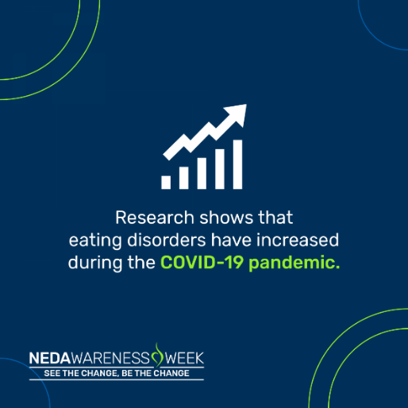
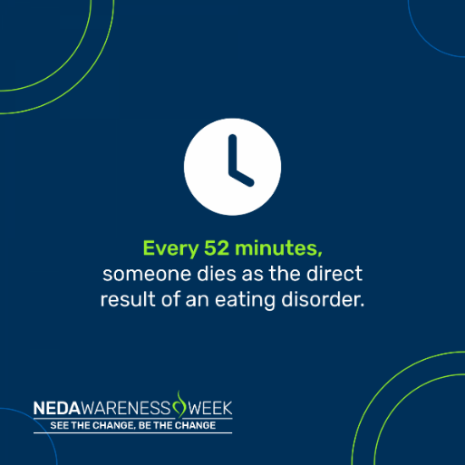
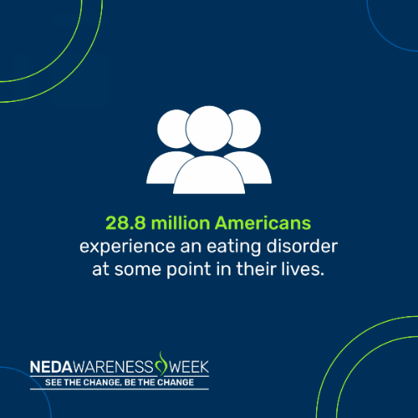
Friday, February 25: NEDA’s Tool Kit

Caption for Facebook/Twitter/Facebook: Prevalence of eating disorders has continued to rise, especially in recent years. It is more important than ever that we fight for accessible and equitable eating disorder treatment for everyone and provide education on the seriousness of this illness. #BetheChange #SeetheChange
*All three images will be shared in one post.

Saturday, February 26
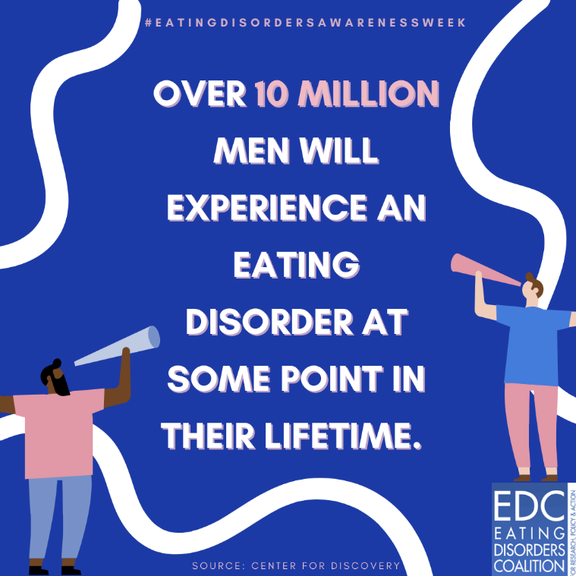
Caption for Facebook/Instagram: Did you know? Around 33% of those experiencing an eating disorder in their lifetime are men – this is over 10 million individuals. Despite this high prevalence, men regularly go undiagnosed with eating disorders due to several factors including stigma and lack of training for health professionals to recognize eating disorder symptoms in men. It is important that when we talk about #eatingdisorders, we include everyone and remember that individuals experiencing eating disorders are diverse.
Caption for Twitter: Over 10 million men will experience an eating disorder in their lifetime. Despite this high prevalence, men regularly go undiagnosed. It is important that when we talk about #eatingdisorders, we include everyone and remember that individuals experiencing eating disorders are diverse.

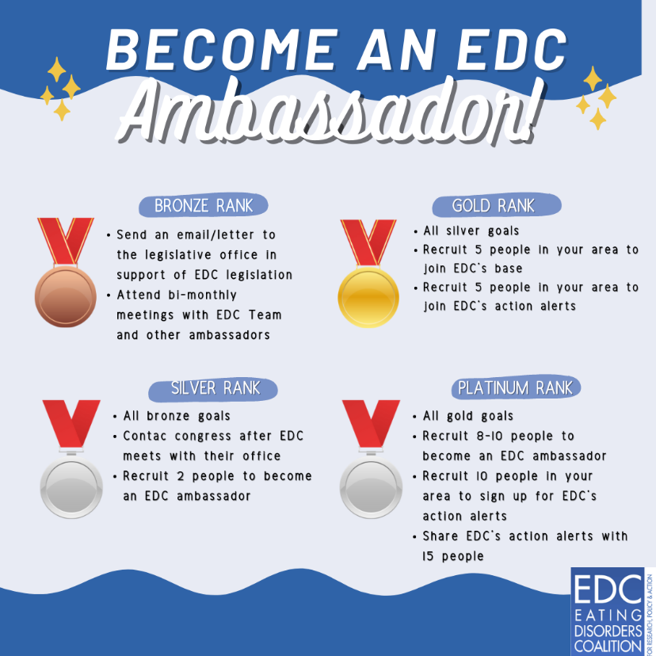
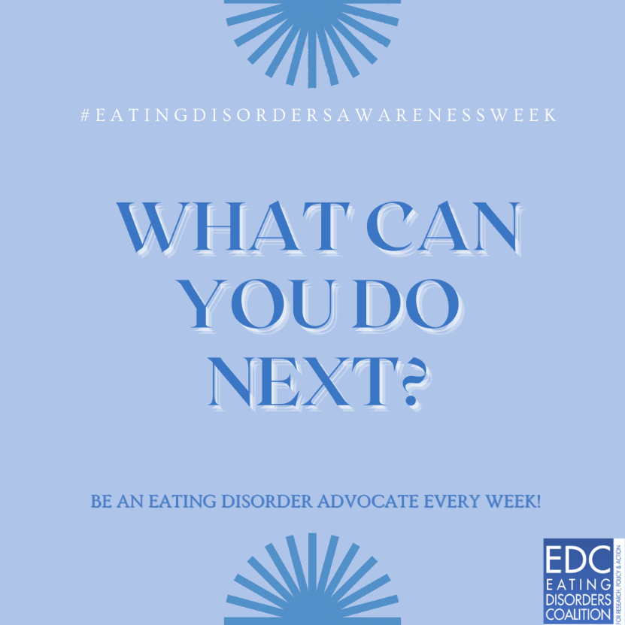
Sunday February 27: Wrap Up

Caption for Facebook/Twitter/Instagram: Although today is the last day of Eating Disorders Awareness Week, it is not the last chance for you to get involved. Become an EDC Ambassador and/or take part in their Action Alerts! To become an EDC Ambassador: https://bit.ly/3HTOwIc. To sign up for action alerts: https://bit.ly/31xd75B. #eatingdisordersawarenessweek
*Both images shared in one post.
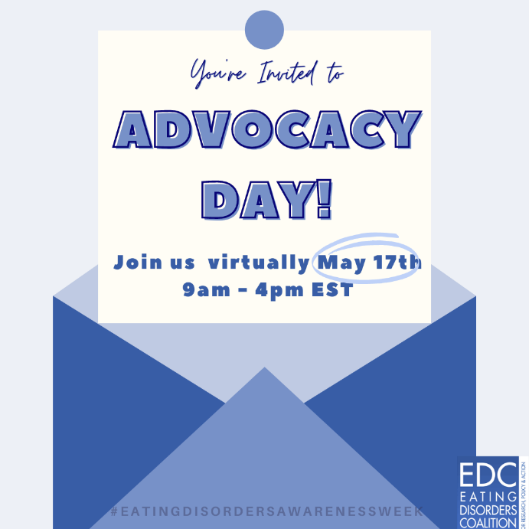
Caption for Facebook/Twitter/Instagram: You’re invited to EDC’s Virtual Advocacy Day happening May 17th. Register Today! https://bit.ly/3rQCBoT #eatingdisorder #eatingdisorderawarenessweek

