Support Eating Disorders Coalition
Virtual Advocacy Day 2022

Social Media Toolkit
Tuesday, May 17, 2022
Contents
Background: 2
Legislation: 2
Directions: 3
Captions & Graphics: 3
Kids Online Safety 3
KIDS ONLINE SAFETY ACT CAPTION: 3
KIDS ONLINE SAFETY ACT CAPTION: 4
KIDS ONLINE SAFETY ACT CAPTION: 4
Anna Westin Legacy Act 9
ANNA WESTIN LEGACY ACT CAPTION: 9
ANNA WESTIN LEGACY ACT CAPTION: 9
ANNA WESTIN LEGACY ACT CAPTION: 9

Background:

The Eating Disorders Coalition for Research, Policy & Action brings advocates together once a year to educate Members of Congress and push for important policy initiatives. Advocacy days provide the opportunity for constituents to connect with their Representatives and Senators to influence federal policy and make a difference in the lives of those affected by eating disorders.
If you are unable to attend this year’s Virtual Advocacy Day, there are still ways to engage your Members of Congress. This toolkit provides sample social media captions and graphics you can use to encourage your network to advocate for policies that would provide support for people affected by eating disorders (by emailing and tweeting their Members of Congress).

Legislation:
We have TWO legislative goals for this year’s advocacy day:
- Increase co-sponsors for the Kids Online Safety Act (S. 3663), urge Senate Commerce Committee to advance the legislation by the end of May, and urge Representatives to become original co-sponsors and introduce the legislation in in the House of Representatives.

  - This legislation will:
    - Hold big tech accountable through audits and fines to protect users under 18 from social media harms, especially around depression, self-harm, and eating disorders.
    - Provide parents and youth with tools and safeguards to protect a young user’s experience on social media.
    - Allow scientists to access social media company data to conduct research in the public interest.

- Increase co-sponsors for the Anna Westin Legacy Act (S. 3686/H.R. 7249) and urge Members of Congress to include the legislation in the CURES 2.0 mental health package.

  - This legislation will:
    - Reauthorize the Center of Excellence for Eating Disorders to continue training health care professionals to screen, briefly
intervene and refer individuals to treatment for eating disorders (SBIRT) through 2027.
    - Expand the evidence-based SBIRT protocol to the pediatric level.
    - Build adaptive modules for at-risk communities that experience under-identification, including racially diverse and tribal communities, rural communities, men and boys, military families, veterans, and LGBTQ populations.

Directions:
Please support both pieces of legislations by posting:
- One image and caption for the Kids Online Safety Act AND
- One image and caption for the Anna Westin Legacy Act

Please post language/images only on the day of EDC Virtual Advocacy Day,
Tuesday, May 17, 2022.

Captions & Graphics:

Kids Online Safety

KIDS ONLINE SAFETY ACT CAPTION: Today is #EDCHillDay with the @EDCoalition! If you couldn’t attend a meeting but still want Congress to know you support the Kids Online Safety Act, click the link to reach out to your Members of Congress! https://bit.ly/3F2BozC #OurKidsCantWait #KOSAnow

KIDS ONLINE SAFETY ACT CAPTION: Couldn’t make it to @EDCoalition’s #EDCHillDay? You can still be involved and show your support for #EatingDisorders issues! Click the link to reach out to your Members of Congress https://bit.ly/3F2BozC #OurKidsCantWait #KOSAnow
KIDS ONLINE SAFETY ACT CAPTION: Want to make a difference in the lives of people with #EatingDisorders? It takes less than 5 minutes to show your Members of Congress you care about @EDCoalition’s legislative priorities by clicking here: https://bit.ly/3F2BozC #OurKidsCantWait #KOSAnow

Facebook/Instagram Image
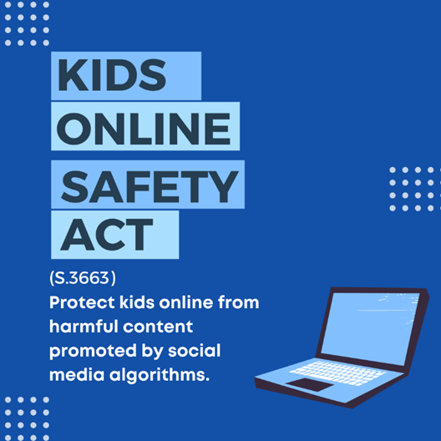

Twitter Image

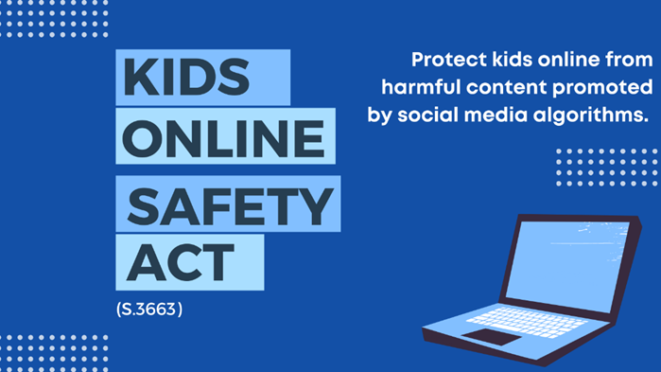

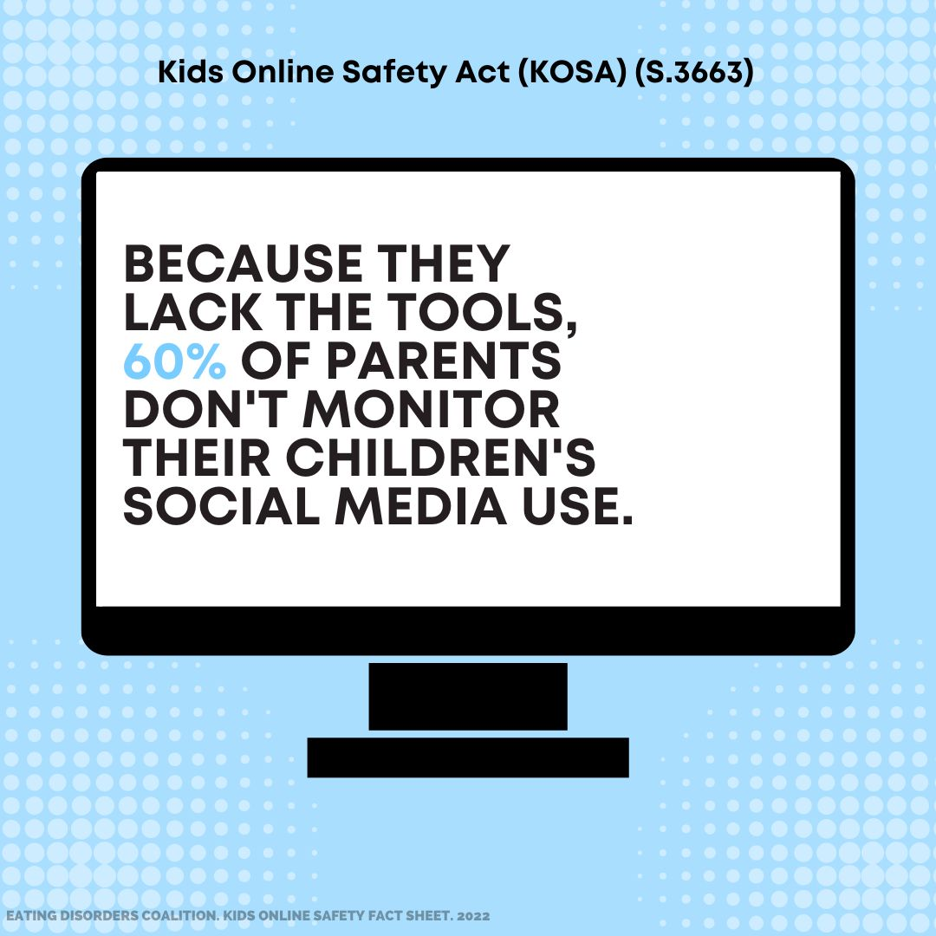
Facebook/Instagram Image

Twitter Image
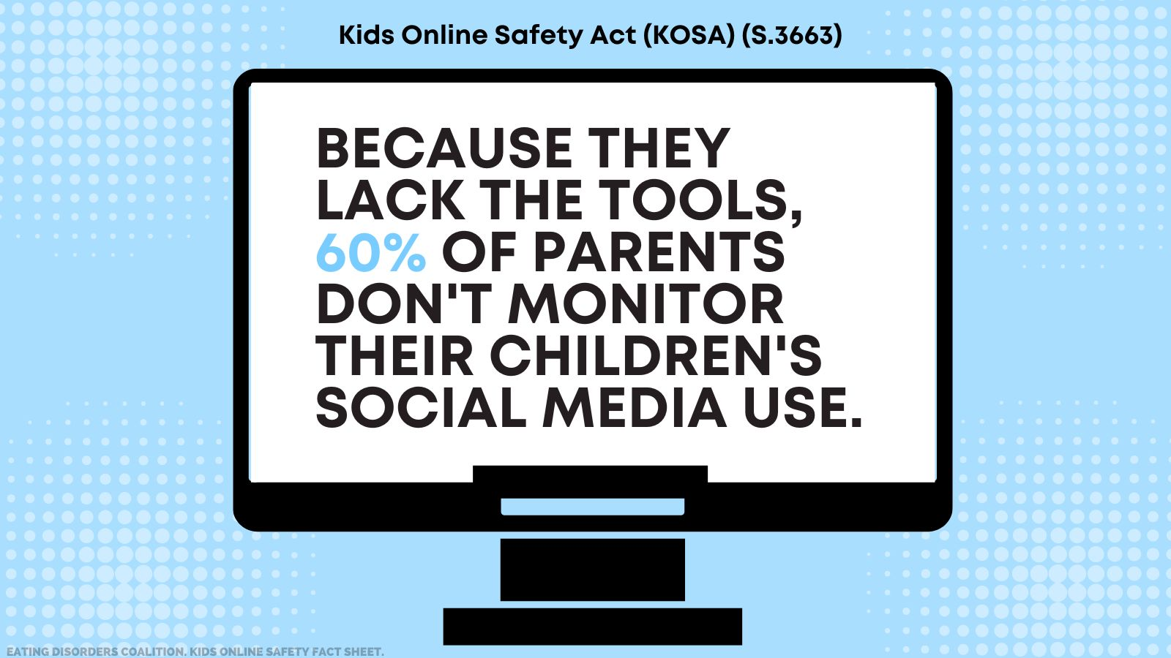

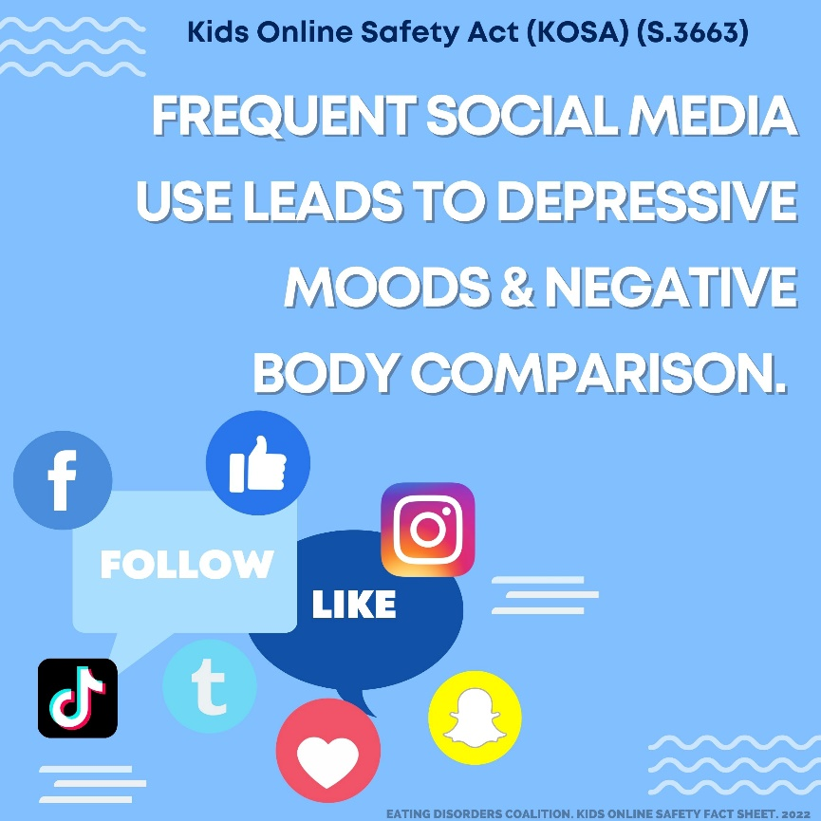
Facebook/Instagram Image

Twitter Image
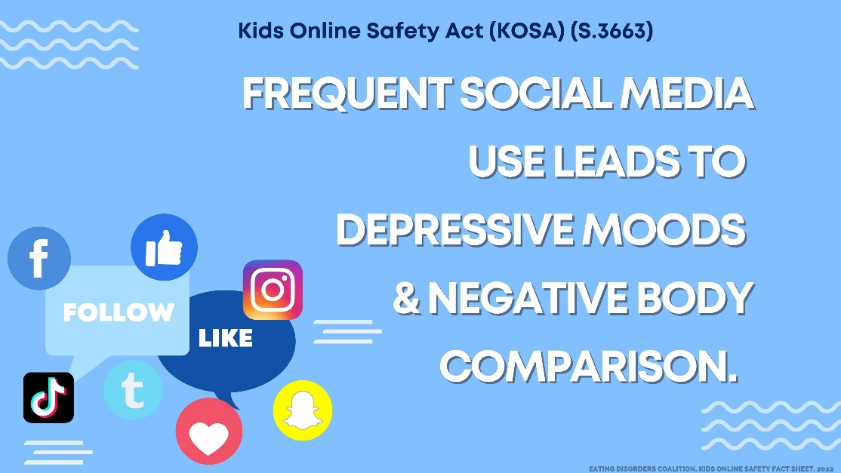

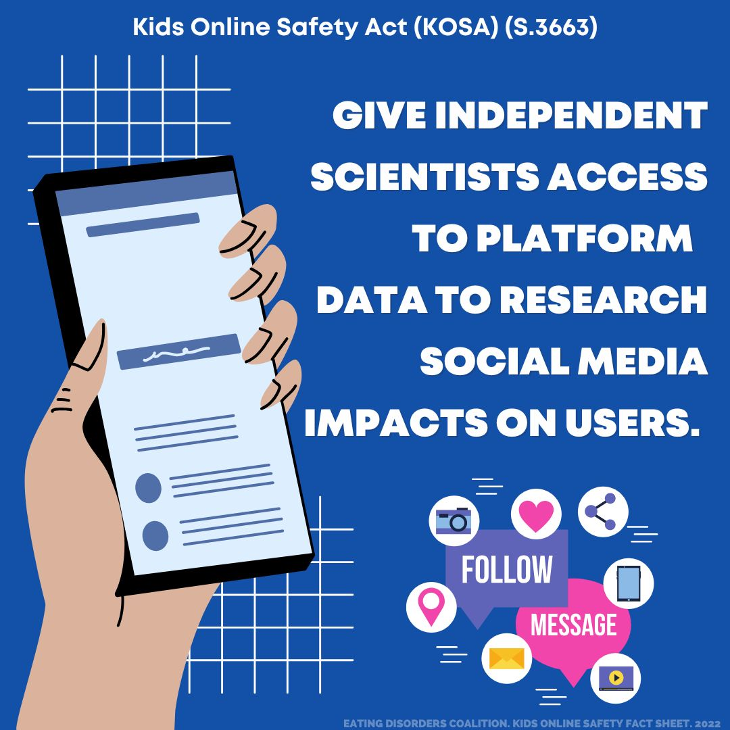
Facebook/Instagram Image

Twitter Image
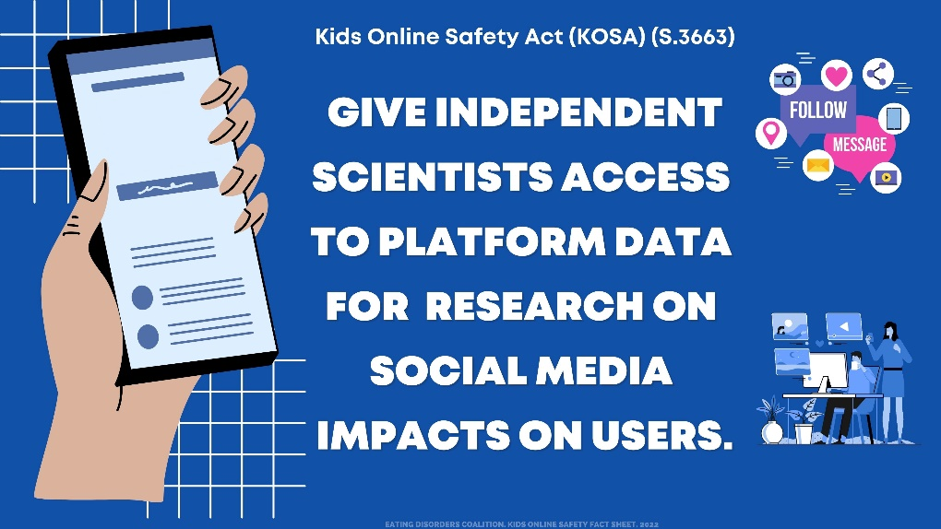

Facebook/Instagram Image
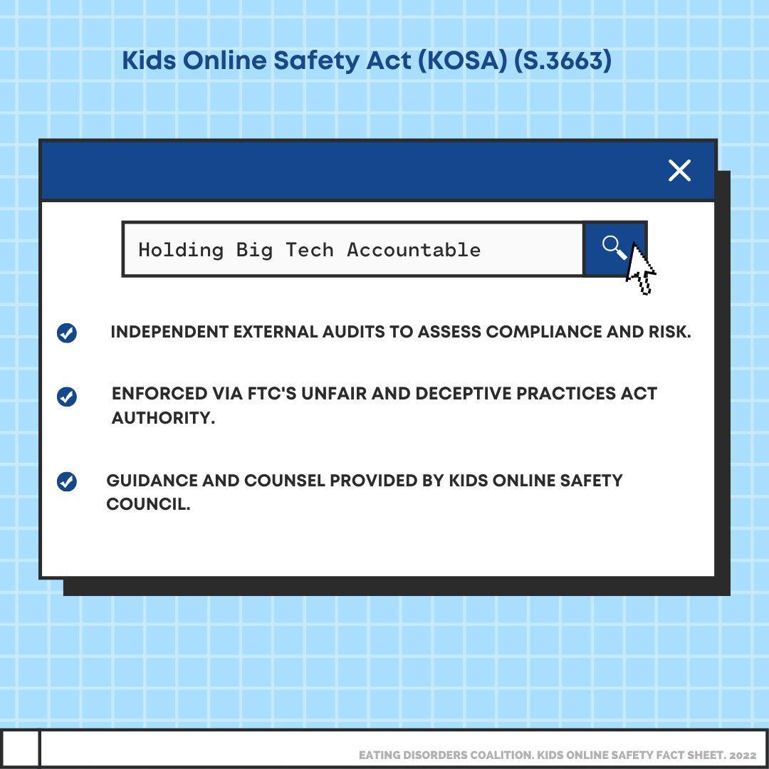

Twitter Image
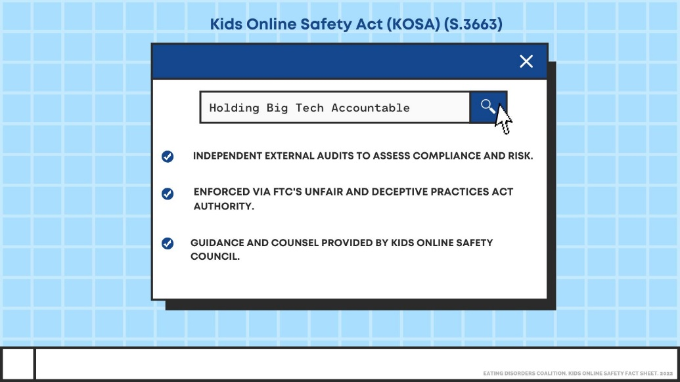

Anna Westin Legacy Act

ANNA WESTIN LEGACY ACT CAPTION: Today is #EDCHillDay with the @EDCoalition! If you couldn’t attend a meeting but still want Congress to know you support the Anna Westin Legacy Act, click the link to reach out to your Members of Congress! https://bit.ly/33qscXG #AWLA #MayYourDreamingNeverEnd
ANNA WESTIN LEGACY ACT CAPTION: Couldn’t make it to @EDCoalition’s #EDCHillDay? You can still be involved and show your support for #EatingDisorders issues! Click the link to reach out to your Members of Congress. https://bit.ly/33qscXG #AWLA #MayYourDreamingNeverEnd
ANNA WESTIN LEGACY ACT CAPTION: Want to make a difference in the lives of people with #EatingDisorders? It takes less than 5 minutes to show your Members of Congress you care about @EDCoalition’s legislative priorities by clicking here: https://bit.ly/33qscXG #AWLA #MayYourDreamingNeverEnd

IMAGES ON NEXT PAGES

Facebook/Instagram Image
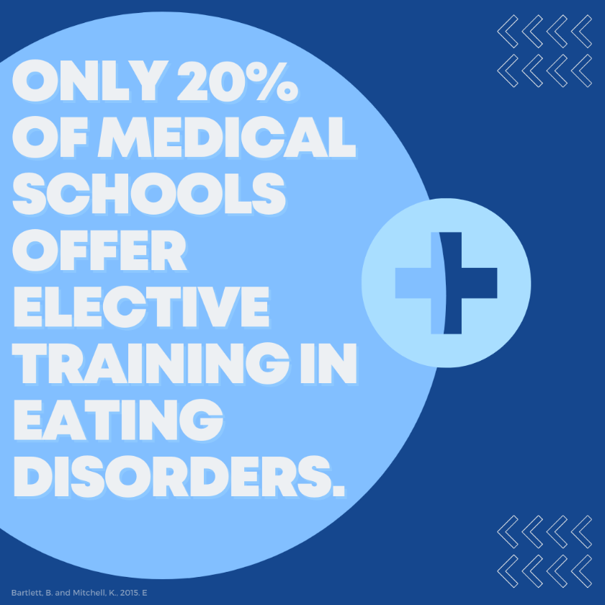

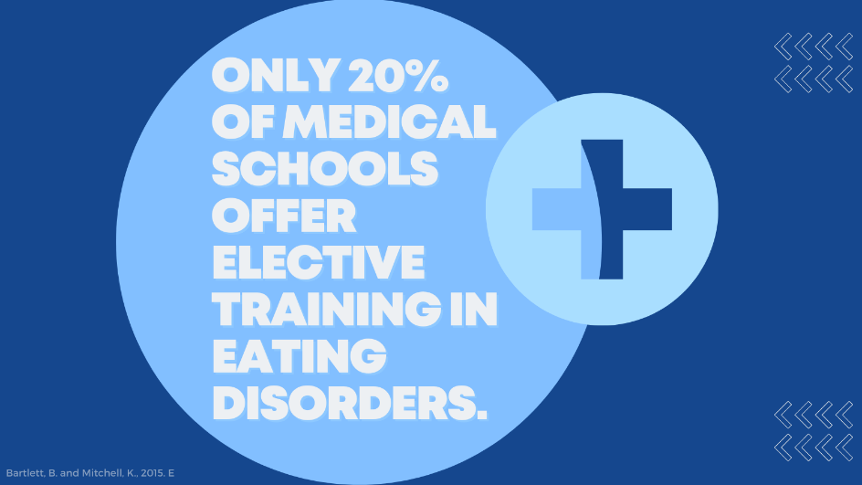
Twitter Image

Facebook/Instagram Image
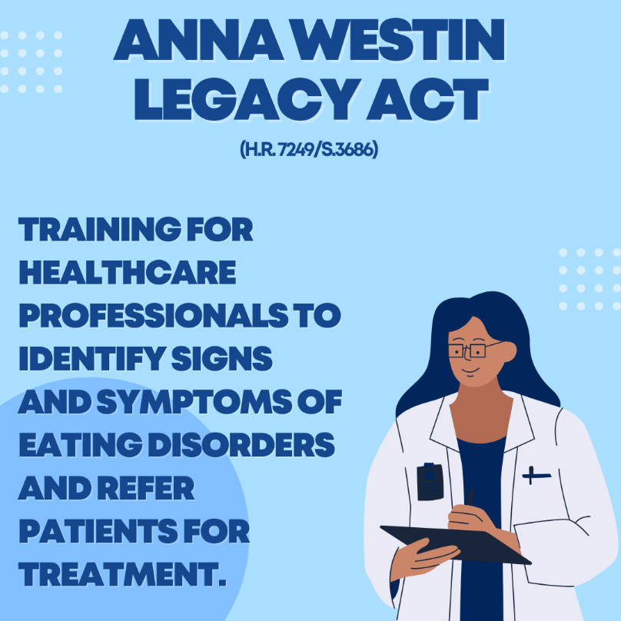

Twitter Image

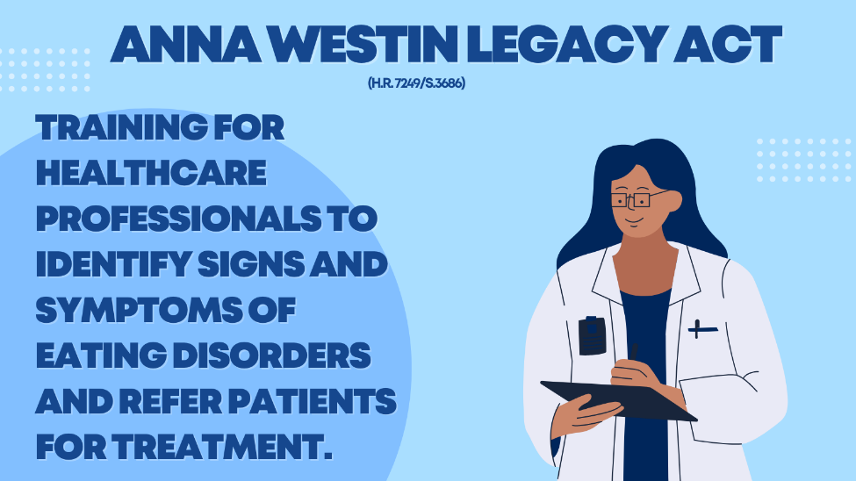

Facebook/Instagram Image
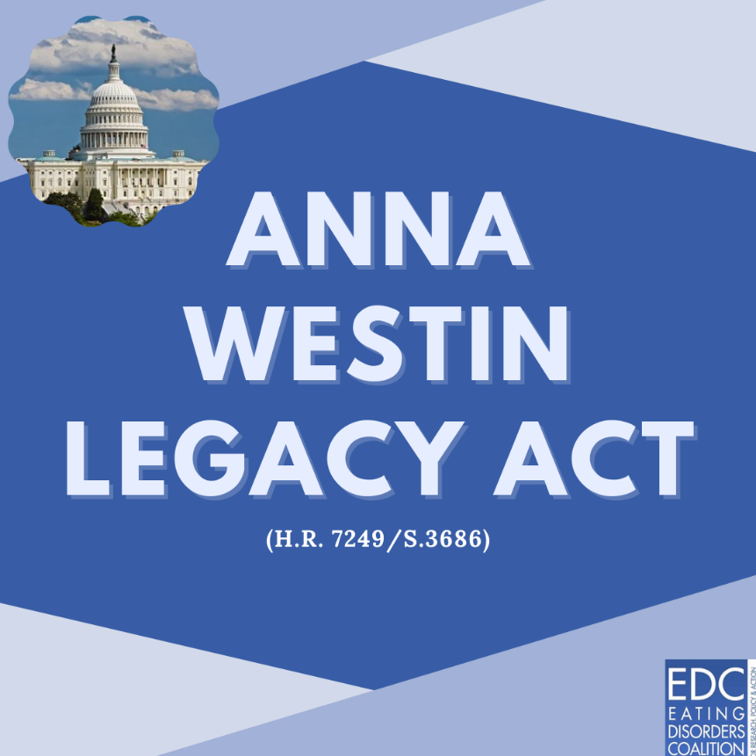

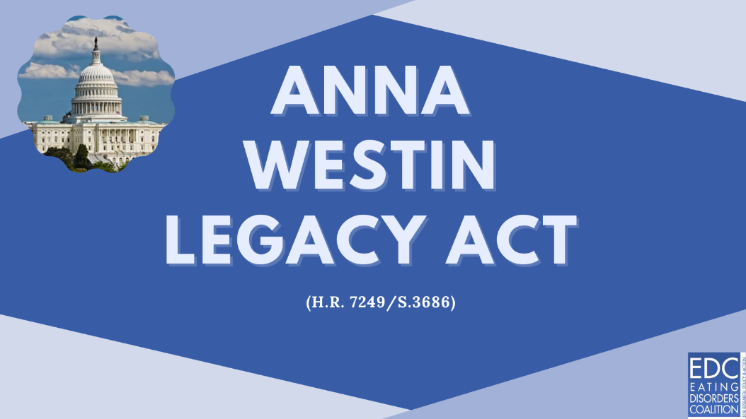

Twitter Image

